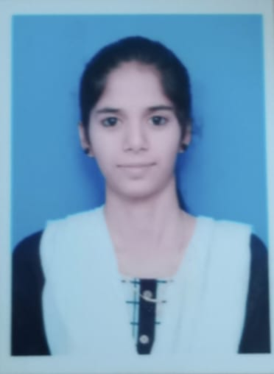 PALLAVI R

**Contact No:** 8220643078

**Email Id:** pallavipallavi2240@gmail.com

**Linkedin id:** <https://www.linkedin.com/in/palrlavi-r-0950b52a>

**Summary**

A self-motivated student studying electronics and communication engineering and got excited to learn about web development which is out my domain and my interest in this made me to know more things about this. Now looking for an internship where I can use my web development skills on both front end and back-end development.

**SKILL HIGHLIGHTS**

* Problem solving
* Time management
* Logical thinking
* Team work

**INTERNSHIPS**

**PANTECH e LEARNING (18.07.2022 to 05.08.2022)**

* Underwent an internship training course in the Python Programming.
* During this period, I had exposure to various things about python programming and gained knowledge on backend development using python. Python applications and logical thinking in coding.

# EDUCATIONAL QUALIFICATION

|  |  |  |  |  |
| --- | --- | --- | --- | --- |
| **DEGREE** | **COURSE** | **INSTITUTION** | **COUNTRY** | **YEAR OF PASSING** |
| Bachelor of Engineering | Electronics and Communication Engineering | Karpagam Academy of Higher Education | INDIA | 2025 |
| HSC | Computer Science | Maharishi Vidya  Mandir | INDIA | 2021 |
| SSLC | - | Parimalam Matriculation School | INDIA | 2019 |

**AREA OF INTREST**

* Embedded C
* VLSI

**TECHNICAL SKILLS**

* C programming
* Python
* HTML
* CSS
* SQL
* Java(basics)

# CERTIFICATES

* Certified in Introduction to Python by Infosys Springboard
* Completed Data Analysis with Python in IBM

**PERSONAL DETAILS**

**ADDRESS:**22/3, nattar street near mg road Hosur 635109

**DATE OF BIRTH:** 10-02-2004

**FATHER’S NAME:** RAMAKRISHNA CHARY G

**NATIONALITY:** INDIAN

**KNOWN LANGUAGES:**

* + TAMIL
  + ENGLISH
  + Telugu
  + KANNADA

# DECLARATION

I hereby confirm that all the details furnished above are authentic and accurate ttthe best of my belief.

**PALLAVI R**